

**Project Document**

**Name :Gokul S**

**Register Number :720722110008**

**Department :B.Tech IT**

**Year :2nd Year**

**Project Title**

Design Thinking In Uber

**Template Name**

Wall of work

**Problem Statement**

Inspired by the vibrant cultural tapestry of our community, this mural project aims to transform a dull wall into a dynamic reflection of our shared experiences, celebrating diversity, unity, and the beauty of our collective story.

**Project description**

**Introduction:**

**Uber is embarking on a transformative journey to enhance its task management processes through a design thinking approach. The project aims to reimagine the traditional task board by introducing a dynamic "Wall of Work" that fosters collaboration, transparency, and efficiency across teams and projects.**

**Features:**

**Visual Collaboration: The Wall of Work will provide a visually engaging and intuitive interface, allowing team members to collaborate seamlessly on task management activities.**

**Agile Task Management: Leveraging agile principles, the Wall of Work will facilitate the organization of tasks into Backlog, Up Next, Doing, and Done columns, enabling teams to prioritize work and track progress effectively.**

**Personalization: The Wall of Work will offer customizable views and filters, empowering users to tailor their task boards to suit their unique preferences and workflows.**

**Real-time Updates: Integrated communication and notification features will ensure that team members stay informed about task updates, changes, and deadlines in real-time.**

**Continuous Improvement: The project will adopt a feedback-driven approach, soliciting input from users throughout the design and implementation process to iteratively enhance the Wall of Work solution.**

**transparent communication, the Wall of Work**

**Benefits:**

**Enhanced Productivity: The Wall of Work will streamline task management workflows, reducing manual effort and enabling teams to focus on delivering value more efficiently.**

**Improved Collaboration: By centralizing task-related information and fostering will facilitate collaboration among team members, leading to better outcomes and increased innovation.**

**Increased Visibility: With clear visibility into task status and progress, stakeholders will have greater confidence in project delivery timelines and outcomes, fostering trust and accountability within the organization.**

**Agile Adaptation: The Wall of Work's flexible and customizable design will enable teams to adapt quickly to changing priorities and requirements, enhancing agility and responsiveness in a dynamic business environment.**

**Empowered Teams: By empowering teams with the tools and autonomy to manage their work effectively, the Wall of Work will cultivate a culture of ownership, empowerment, and continuous improvement within Uber.**

**Conclusion:**

**The design thinking project to develop Uber's Wall of Work represents a significant step towards transforming how tasks are managed and executed within the organization. By leveraging user-centric design principles and embracing collaboration and innovation, Uber is poised to revolutionize its task management processes, driving productivity, efficiency, and success across the organization.**

**Worked Template with explanation**

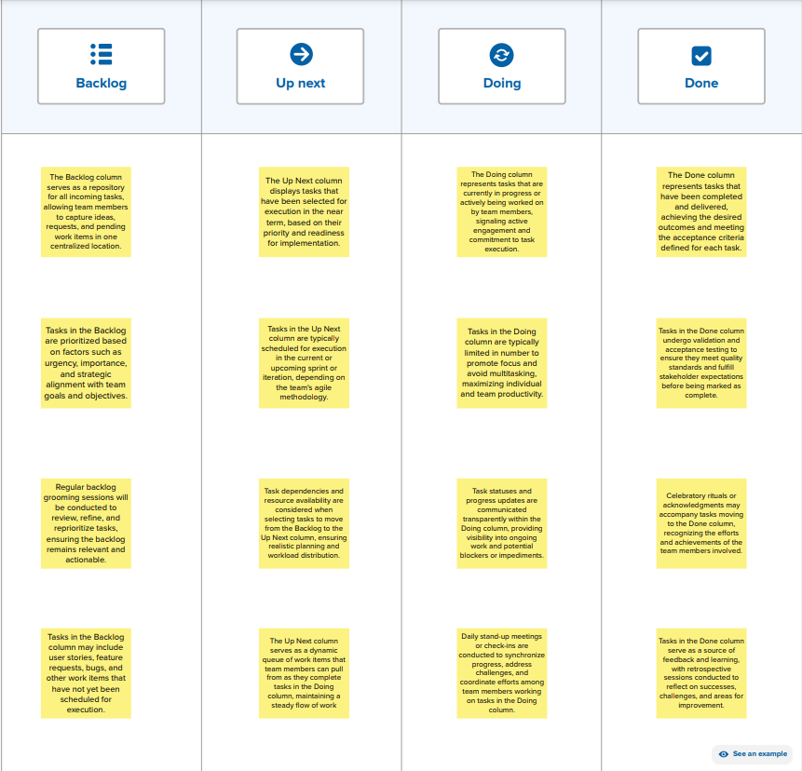

**The template for the Wall of Work serves as a blueprint for organizing tasks and facilitating collaboration within teams. Here's an explanation of the key components:**

**Column Structure: The Wall of Work template typically consists of four main columns: Backlog, Up Next, Doing, and Done. Each column represents a different stage in the task management process, from initial ideation to completion.**

**Backlog: The Backlog column is where all incoming tasks are captured and stored. This column serves as a repository for ideas, requests, and pending work items that have not yet been scheduled for execution.**

**Up Next: The Up Next column displays tasks that have been selected for execution in the near term. Tasks in this column are typically prioritized based on their importance and readiness for implementation.**

**Doing: The Doing column represents tasks that are currently in progress or actively being worked on by team members. This column provides visibility into ongoing work and facilitates coordination among team members.**

**Done: The Done column contains tasks that have been completed and delivered. This column serves as a record of achievements and provides feedback on the team's progress and performance.**

**Task Cards: Tasks within each column are represented as individual cards. Each card contains essential information about the task, such as the title, description, assignee, due date, and status.**

**Collaborative Features: The Wall of Work template may include features such as task assignment, comments, and attachments, allowing team members to collaborate and communicate effectively on task-related activities.**

**Customization Options: The template may offer customization options, such as the ability to add custom columns, create task tags, or apply filters, allowing teams to adapt the Wall of Work to their specific workflows and requirements.**

**Visual Design: The template is designed to be visually engaging and easy to navigate, with clear visual cues and color-coded elements to indicate task status and priority.**

**Accessibility: The template prioritizes accessibility, ensuring that it is usable by all team members, including those with disabilities, and optimized for various devices and screen sizes.**

**GitHub Link:**